**HW5 Report**

**Size of the fixed length sample    Overlap (0-X%)    K- value  Classifier    Accuracy**

**12 * 3 0 19 RandomForest 0.77-0.8**

**Standard K means**

**Train test Split: 75%train, 25%test (The train error and test error does not have big difference, which means to avoid overfit problem)**

**Selection of k（test when length = 32）: Selection of fixed length（test when k = 19）:**

**K length**

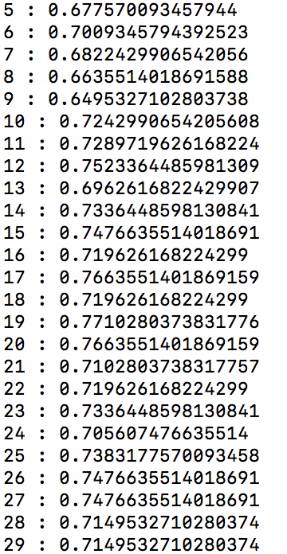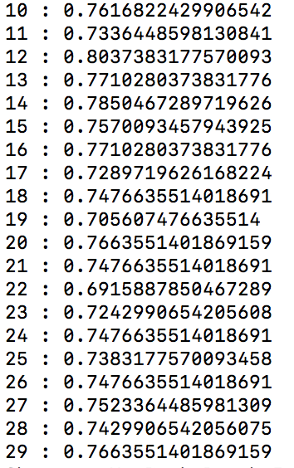

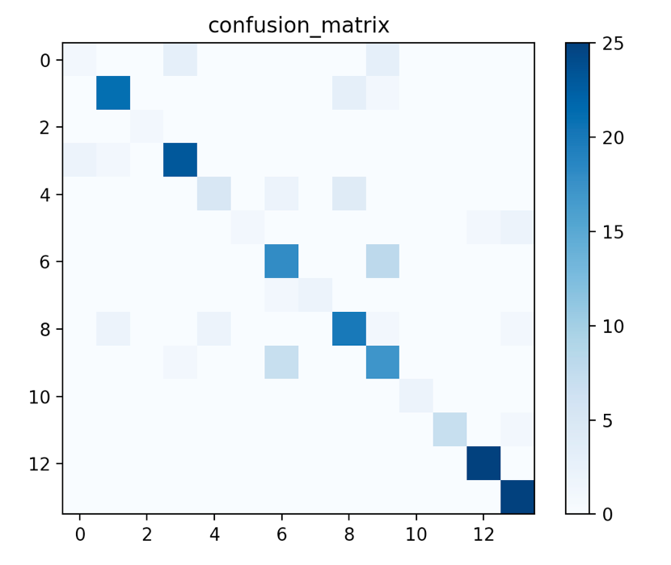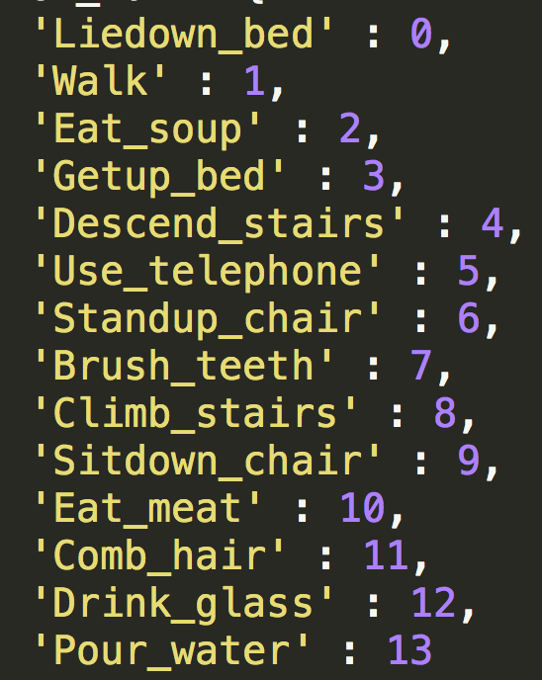

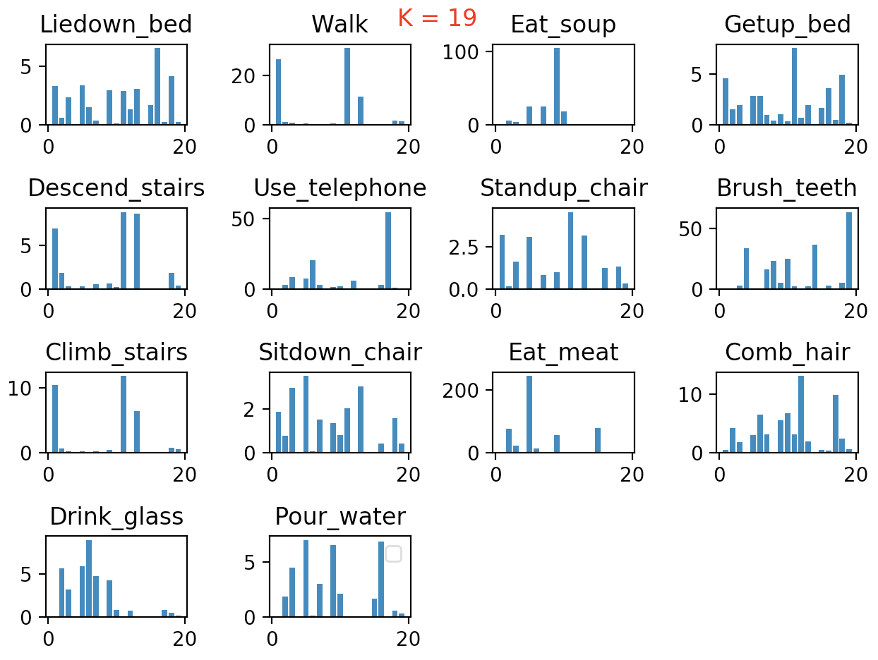

1. segmentation of the vector:

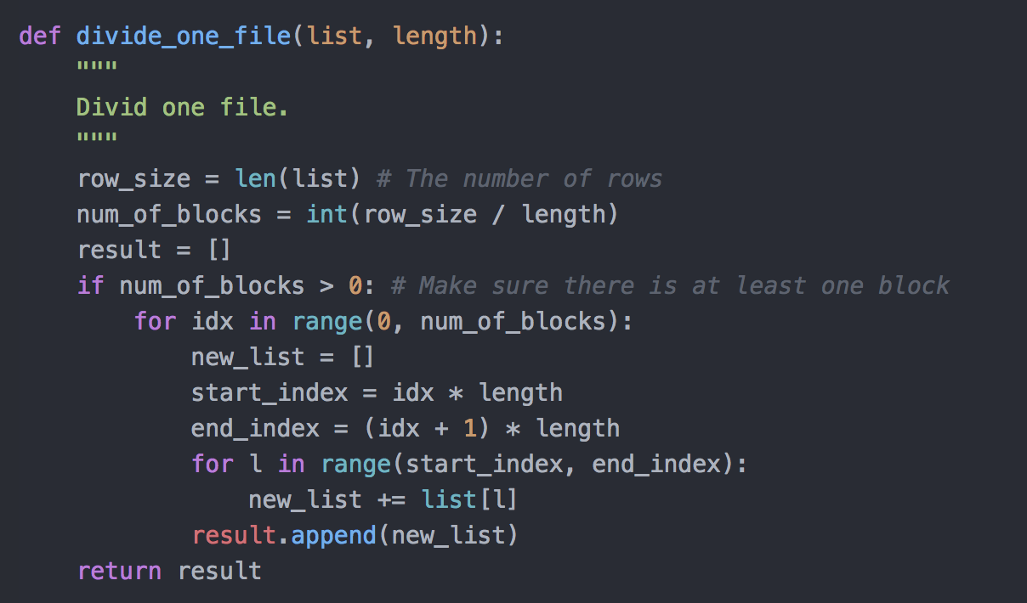

2. k-means

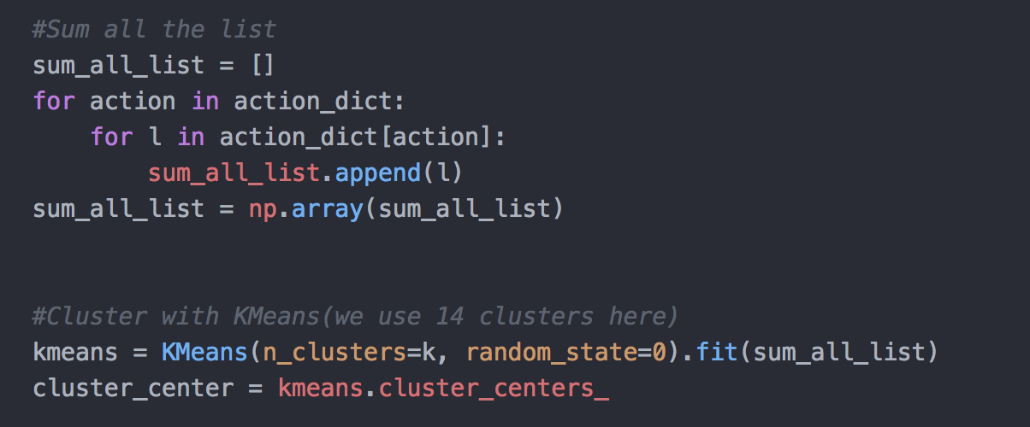

3. generating the histogram

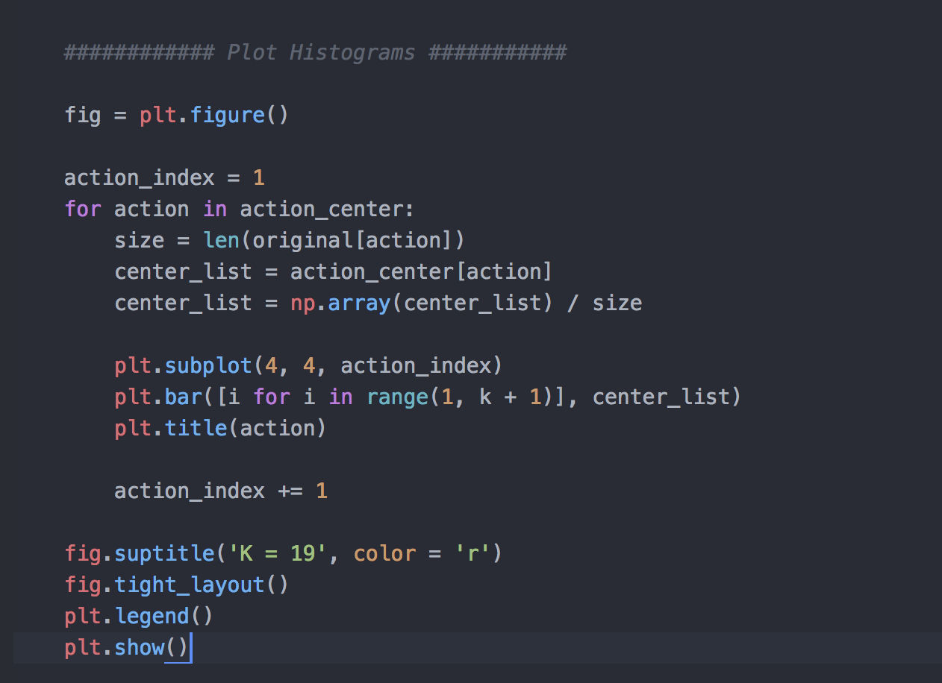

4. classification

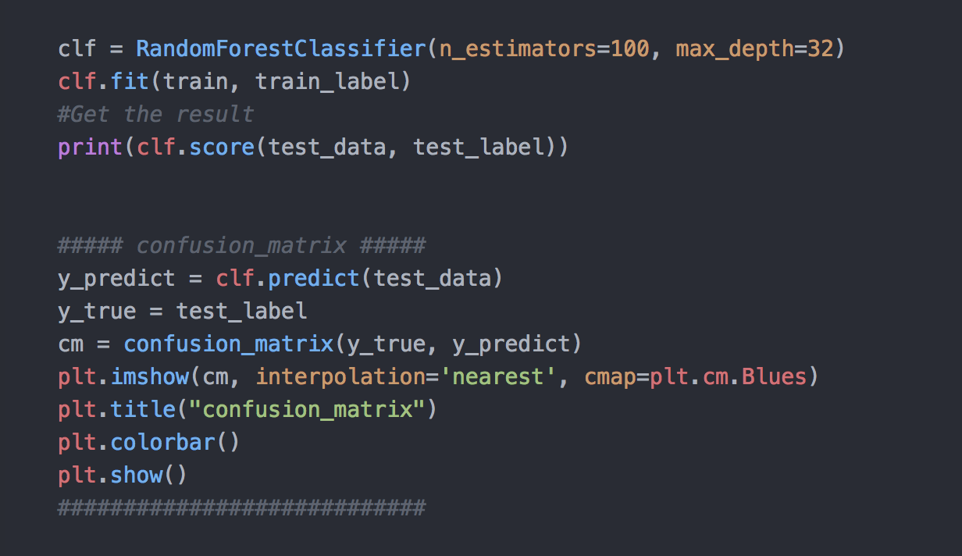

**Relevant Code:**

**Divide the file into segments**

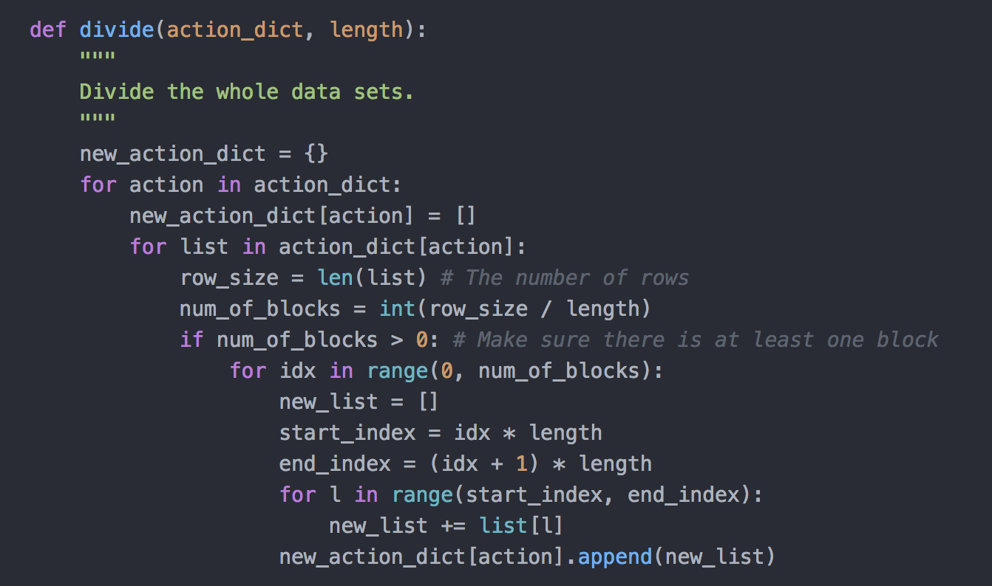

**Generating training matrices and training labels.**

